WEATHERWISE AI
Intelligent weather forecasts and insights
Project Documentation

Project Details
Project Name | WeatherWise AI
Description | RESTful backend platform delivering real-time weather metrics with AI-generated insights via Google Gemini
Tech Stack | Node.js, Express.js, MongoDB, Mongoose ODM, Google Gemini API

Team Details
Name | Role
Santhosh kumar M | Team Leader
Karthikeyan S | Team Member
Siva A | Team Member
Arunkumar N | Team Member
Dhanush L | Team Member

1. Introduction
WeatherWise AI is a robust RESTful backend platform built with Node.js and Express.js. It uses MongoDB with the Mongoose ODM for data persistence and delivers real-time weather metrics enriched with intelligent insights generated by Google Gemini.

1.1 Objectives
- Provide accurate, real-time weather data through a clean REST API.
- Turn raw weather metrics into easy-to-understand, AI-generated insights.
- Store and manage application data reliably in MongoDB.
- Offer a scalable, maintainable backend that client apps can integrate easily.

2. Technology Stack
Technology | Purpose
Node.js | JavaScript runtime for the server
Express.js | Web framework for routing and middleware
MongoDB | NoSQL database for data storage
Mongoose | ODM for schemas, models and validation
Google Gemini API | Generates intelligent weather insights

3. System Architecture
The platform follows a layered architecture:
- Client: any web or mobile app that sends HTTP requests to the API.
- API layer (Express.js): routes, middleware and request validation.
- Service layer: fetches weather metrics and calls the Gemini API for insights.
- Data layer (Mongoose + MongoDB): models and persistence.

3.1 Request Flow
- The client sends a request to a REST endpoint.
- Express routes and validates the request.
- The service layer retrieves real-time weather metrics.
- The metrics are passed to Google Gemini to generate insights.
- Results are saved to MongoDB where needed and returned as JSON.

4. Key Features
- Real-time weather metrics delivery.
- AI-powered forecasts and insights using Google Gemini.
- RESTful API design with JSON responses.
- Persistent storage with MongoDB and Mongoose.
- Modular, scalable Node.js/Express codebase.

5. Installation and Setup

5.1 Prerequisites
- Node.js (LTS version) and npm
- MongoDB (local instance or MongoDB Atlas)
- Google Gemini API key
- Weather data provider API key (if applicable)

5.2 Steps
1. Clone the repository and open the project folder.
2. Install dependencies:
npm install
3. Create a .env file and configure it as described in 5.3.
4. Start the server:
npm start
The project follows the folder structure shown below.
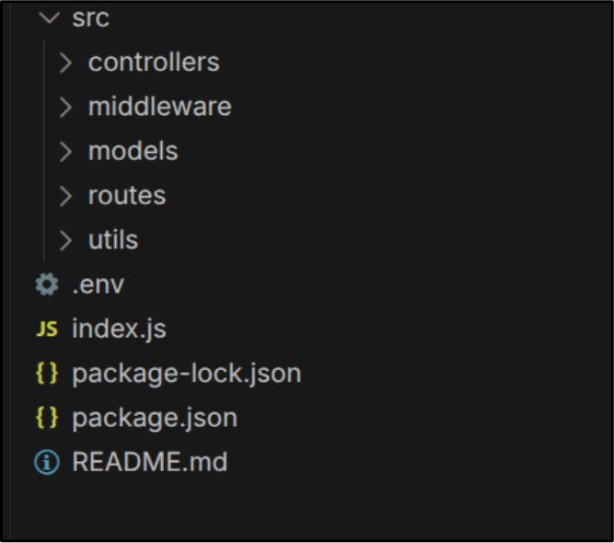

5.3 Environment Configuration
Create a .env file in the project root and configure the required environment variables.
PORT=5000
MONGO_URI=your_mongodb_connection_string
JWT_SECRET=your_jwt_secret
GEMINI_API_KEY=your_gemini_api_key

6. API Endpoints
Replace the rows below with the actual endpoints of the project.
Method | Endpoint | Description
GET | /api/weather/:city | [Get current weather metrics for a city]
GET | /api/insights/:city | [Get AI-generated weather insights]

7. Error Handling and Security
- Centralized error-handling middleware returning consistent JSON errors.
- API keys and secrets stored in environment variables, never in source code.
- Input validation on incoming requests.

8. Future Enhancements
- Multi-day and location-based forecasts.
- User accounts with saved locations and alerts.
- Caching to reduce external API calls.
- Frontend dashboard for visualizing weather and insights.

9. Demo Video
Watch the project demonstration using the link below.
Video Link https://drive.google.com/file/d/1SbCQ14GVDXpCDkD3JmDVukVKwzJVxC2Q/view?usp=drivesdk

